Static vs non static

1. **Calling a Static Method from Another Static Method:**

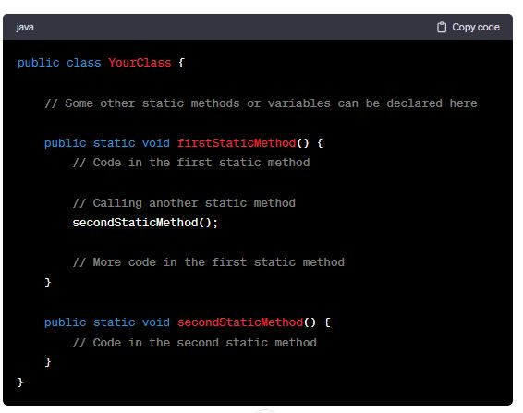

-------------------------------------------------------------------------------------------------

1. **Calling a Non-Static Method from Another Non-Static Method:**

---------------------------------------------------------------------------------------

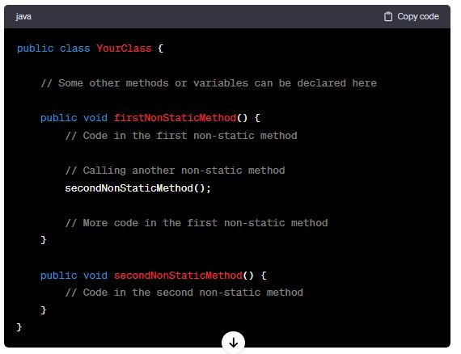

1. **Calling a Non-Static Method from a Static Method:**

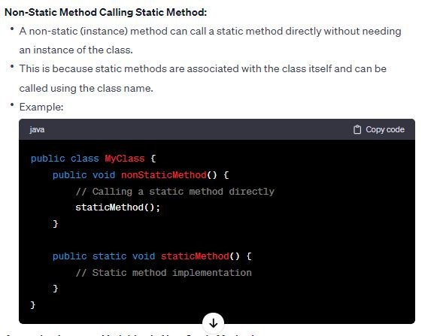

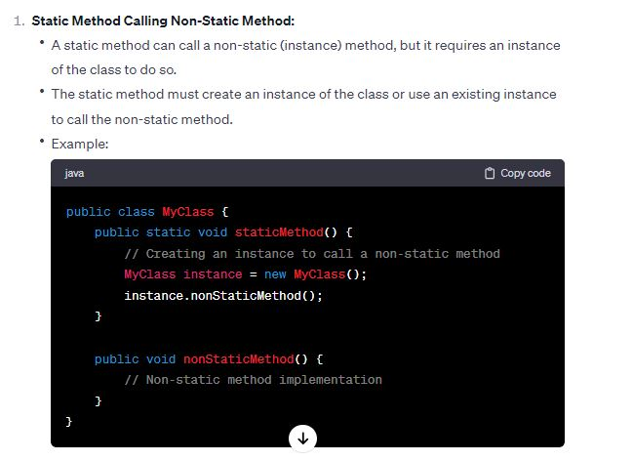

1. **Static Variables and Static Methods:**

**-------------------------------------------------------------------------------------**

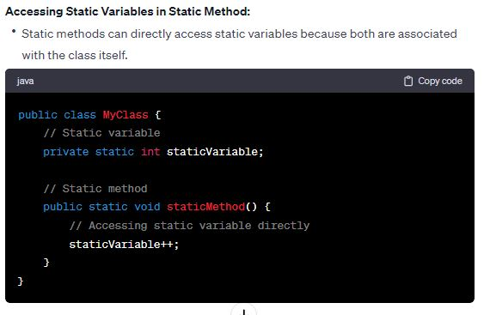

-----------------------------------------------------------------------------------

1. **Non-Static Variables and Non-Static Methods:**



